SIMATS ENGINEERING (SAVEETHA SCHOOL OF ENGINEERING)
Department of Computer Science and Engineering
CO2 ASSESSMENT TOOL 1 – Scenario-Based Requirement Analysis

Course Code: | CSA10 | Course Title: | Software Engineering
CO Assessed: | CO2 | Assessment: | Assessment Tool 2 – Scenario-Based Requirement Analysis
Weightage: | 20% | Total Marks: | 25
CO2 Statement: | Perform detailed requirements analysis, design scalable architectures, and prioritize features with a focus on cross-disciplinary skills
Student Name: | P. Pawan Teja | Reg. No.: | 192372303
Date: | 03/08/2026 | Duration: | 60 minutes

Code of Conduct
I P. Pawan Teja / 192372303 (Name / Reg No) certify that this submission is my original work and that I have adhered to the guidelines specified for this assessment. I understand that any violation of academic integrity rules will result in disciplinary action.
Signature of the Student: P. Pawan Teja

Assigned Scenario: Smart Building Occupancy Prediction and Space Utilization Platform

1. Study and Analysis of the Scenario

1.1 Problem Statement
Commercial buildings, educational institutions, and corporate offices require intelligent space management to improve energy efficiency and optimize facility utilization. AI, IoT occupancy sensors, and cloud analytics enable organizations to understand occupancy trends and manage building resources efficiently.
Large buildings often experience inefficient utilization of meeting rooms, classrooms, and office spaces, leading to unnecessary energy consumption and increased operational costs. Manual monitoring methods fail to provide accurate occupancy information. The proposed intelligent occupancy prediction platform collects data from occupancy sensors, access control systems, and scheduling platforms to predict space usage, optimize room allocation, reduce energy waste, and improve facility management decisions.

1.2 Business Domain
Smart building management and facility operations — specifically IoT-driven occupancy sensing, predictive space analytics, and energy management for commercial buildings, educational campuses, and corporate offices.

1.3 Stakeholders
- Facility Manager — monitors occupancy, optimizes room allocation, and plans facility usage.
- Employees / Occupants — book and use rooms/spaces within the building.
- System Administrator — configures sensors, zones, thresholds, and manages user accounts.
- Energy Manager — oversees HVAC/lighting automation and energy consumption.
- Building Owner / Management — uses analytics and reports for strategic facility and sustainability decisions.
- IoT Sensor Network, Access Control System, Scheduling Platform, and HVAC/BMS — external systems that supply or consume data.

1.4 Existing Challenges
- Manual monitoring fails to provide accurate, real-time occupancy information.
- Meeting rooms, classrooms, and offices are frequently under- or over-utilized, wasting space and energy.
- HVAC and lighting often run in unoccupied spaces, increasing operational costs.
- No predictive insight into future occupancy, making room allocation and facility planning reactive rather than proactive.
- Occupancy, access-control, and scheduling data exist in silos rather than a unified analytics platform.

1.5 System Objectives
- Monitor occupancy using IoT sensors in real time.
- Predict future occupancy trends per room/zone.
- Optimize room allocation based on predicted and actual demand.
- Reduce energy consumption through occupancy-driven HVAC/lighting control.
- Generate occupancy and utilization analytics for facility managers and building owners.
- Support smart HVAC control and improve facility planning and building efficiency.

2. Functional and Non-Functional Requirements

2.1 Functional Requirements
ID | Requirement | Priority
FR-01 | The system shall collect real-time occupancy data from IoT sensors installed in rooms, zones, and common areas. | High
FR-02 | The system shall integrate with access control systems to capture entry and exit events for each monitored space. | High
FR-03 | The system shall integrate with scheduling/calendar platforms to import room booking and meeting data. | High
FR-04 | The system shall predict future occupancy trends per room/zone using historical and real-time data (ML-based forecasting). | High
FR-05 | The system shall recommend optimized room allocation based on predicted demand and current utilization. | High
FR-06 | The system shall allow facility managers to view real-time and historical occupancy dashboards. | High
FR-07 | The system shall automatically trigger HVAC and lighting control adjustments based on occupancy levels. | Medium
FR-08 | The system shall generate energy consumption and space-utilization reports for facility and energy managers. | Medium
FR-09 | The system shall send alerts for underutilized, overbooked, or anomalous occupancy in monitored spaces. | Medium
FR-10 | The system shall allow employees to search and book available rooms based on predicted availability. | Medium
FR-11 | The system shall allow administrators to configure sensor devices, zones, and occupancy thresholds. | High
FR-12 | The system shall maintain an audit log of sensor data, predictions, allocation decisions, and system actions. | Medium

2.2 Non-Functional Requirements
Category | Requirement
Performance | The system shall ingest sensor data streams and refresh the occupancy dashboard within 5 seconds under normal load.
Security | All sensor, access-control, and occupancy data shall be encrypted in transit (TLS 1.2+) and at rest; access shall be role-based (occupant, facility manager, energy manager, admin).
Reliability | The system shall maintain 99.5% uptime and gracefully handle sensor/network failures via cached last-known-state fallback.
Usability | The dashboard shall be usable by facility managers without specialized technical training and shall follow accessible design (WCAG 2.1 AA).
Scalability | The architecture shall scale from a single building/floor pilot to a multi-building campus with thousands of concurrent sensor feeds.
Maintainability | The system shall be modular (separate ingestion, prediction, allocation, and reporting services) to allow independent updates.
Availability | Core monitoring and dashboard functionality shall be available 24/7, excluding scheduled maintenance windows.
Interoperability | The system shall integrate via open APIs/protocols (e.g., MQTT, REST) with IoT sensor gateways, access control, calendar platforms, and the building's HVAC/BMS.

3. Actors and Use Cases

3.1 Actors
Actor | Type | Key Use Cases
Facility Manager | Primary | Monitor Real-time Occupancy, Predict Occupancy Trends, Optimize Room Allocation, View Occupancy Analytics Dashboard, Receive Utilization Alerts, Generate Facility Reports
Employee / Occupant | Primary | Book/Reserve Room, View Occupancy Analytics Dashboard (space availability)
System Administrator | Primary | Configure Sensors & Thresholds, Manage User Accounts, Generate Facility Reports
Energy Manager | Primary | Control HVAC & Lighting Automatically (oversight), View Energy Consumption Reports
IoT Sensors | Secondary (External System) | Feed real-time occupancy counts into the data-ingestion pipeline
Access Control System | Secondary (External System) | Provide entry/exit event data for occupancy calculation
Scheduling/Calendar API | Secondary (External System) | Supply room booking data and receive new reservations
HVAC / BMS System | Secondary (External System) | Receive automated control commands based on predicted/actual occupancy

3.2 Use Case Descriptions
Use Case | Actor(s) | Description
Monitor Real-time Occupancy | Facility Manager, IoT Sensors | System displays live occupancy counts per room/zone sourced from IoT sensors.
Predict Occupancy Trends | Facility Manager | System forecasts future occupancy per space using historical and real-time data.
Optimize Room Allocation | Facility Manager | System recommends the best room/zone allocation based on predicted demand and current usage.
Book / Reserve Room | Employee/Occupant, Scheduling API | Occupant searches and books an available room; the booking syncs with the scheduling platform.
View Occupancy Analytics Dashboard | Facility Manager, Employee/Occupant | Users view real-time/historical occupancy and space-utilization visualizations.
Receive Utilization Alerts | Facility Manager | System notifies the facility manager of underused, overbooked, or anomalous space usage.
Configure Sensors & Thresholds | System Administrator | Admin registers sensors/zones and sets occupancy thresholds used for alerts and automation.
Generate Facility Reports | Facility Manager, System Administrator | System compiles utilization and operational reports for review.
Control HVAC & Lighting Automatically | Energy Manager, HVAC/BMS System | System sends automated control signals to HVAC/lighting based on occupancy levels.
View Energy Consumption Reports | Energy Manager | Energy manager reviews energy usage correlated with occupancy and automation actions.
Manage User Accounts | System Administrator | Admin creates/updates/deactivates user accounts and role permissions.
Ingest Sensor & Access Control Data | IoT Sensors, Access Control System | System continuously ingests and normalizes incoming sensor and access-control event data.
Sync Room Booking Data | Scheduling/Calendar API | System pulls existing bookings and pushes new reservations to keep calendars in sync.

3.3 Use Case Diagram
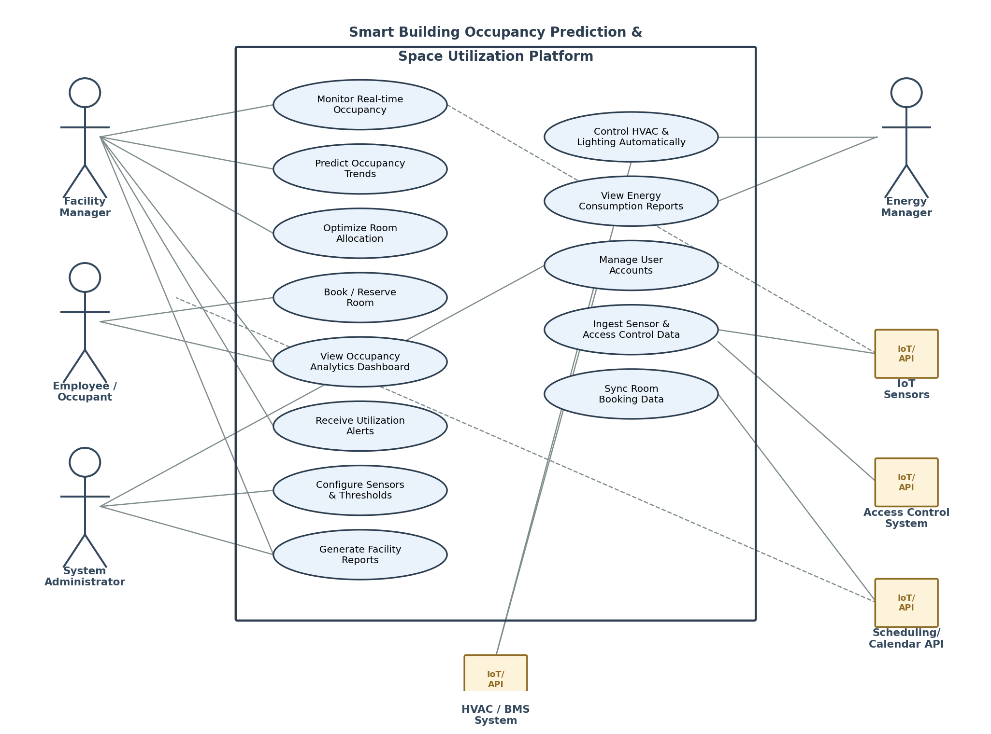
Figure 1: Use Case Diagram – Smart Building Occupancy Prediction and Space Utilization Platform

4. Software Requirement Specification (SRS)

4.1 Introduction
This SRS describes the requirements for a Smart Building Occupancy Prediction and Space Utilization Platform intended to collect data from IoT occupancy sensors, access control systems, and scheduling platforms to predict space usage, optimize room allocation, and support smart energy management across a commercial building or campus.

4.2 Problem Description
Refer to Section 1.1 for the full problem statement. In summary, the system replaces manual, inaccurate occupancy monitoring with a unified IoT- and AI-driven platform that predicts space usage, automates HVAC/lighting control, and gives facility and energy managers actionable analytics to reduce costs and improve utilization.

4.3 Scope of the System
- In scope: real-time occupancy monitoring, occupancy prediction, room allocation optimization, room booking for employees, occupancy/energy dashboards and reports, sensor/threshold configuration, automated HVAC/lighting control triggers, and alerting.
- Out of scope (Phase 1): full building automation of non-HVAC systems (e.g., elevators, security beyond access logging), integration with third-party facility maintenance/ticketing systems, and multi-campus cross-building optimization (planned for a later phase after single-building pilot validation).

4.4 Functional Requirements
See Section 2.1 for the complete list (FR-01 to FR-12).

4.5 Non-Functional Requirements
See Section 2.2 for the complete list (performance, security, reliability, usability, scalability, maintainability, availability, interoperability).

4.6 Use Case Descriptions
See Section 3.2 and the diagram in Section 3.3.

4.7 Data Requirements
- Sensor data: sensor ID, zone/room ID, occupancy count, timestamp, sensor status/health.
- Access control data: badge/entry ID, zone, entry/exit timestamp, direction.
- Scheduling data: room ID, booking ID, organizer, start/end time, attendee count, booking status.
- Prediction data: zone ID, predicted occupancy, prediction time window, model confidence score.
- Energy data: zone/HVAC unit ID, energy consumption reading, timestamp, control action taken.
- Room/space metadata: room ID, capacity, floor, building, room type (meeting room/classroom/office).
- User account data: role (occupant/facility manager/energy manager/admin), credentials (hashed), access permissions.

4.8 External Interface Requirements
- User Interface: web-based analytics dashboard for facility/energy managers and administrators; mobile-friendly booking interface for employees/occupants.
- Hardware Interface: IoT occupancy sensors (e.g., PIR, CO2, camera-based counters) and sensor gateways installed per room/zone.
- Software Interface: integration APIs with the access control system, scheduling/calendar platform (e.g., Outlook/Google Calendar), and the building's HVAC/BMS.
- Communication Interface: MQTT or similar lightweight protocol for sensor data ingestion; HTTPS/REST APIs for dashboard, booking, and third-party integrations.

4.9 System Features
- Real-time occupancy dashboard with per-room/zone live status and historical trends.
- AI-based occupancy prediction engine using historical and streaming sensor data.
- Automated room-allocation recommendations based on predicted demand.
- Occupancy-driven HVAC/lighting automation to reduce energy waste in unoccupied spaces.
- Configurable alerts for underutilized, overbooked, or anomalous space usage.
- Facility and energy analytics reports (utilization rate, energy savings, occupancy trends) for managers and building owners.

5. Assumptions and Constraints

5.1 Assumptions
- IoT occupancy sensors are installed and functioning across all monitored rooms, zones, and common areas.
- The building has adequate network infrastructure (Wi-Fi/LAN or LPWAN) for reliable sensor data transmission.
- Sufficient historical occupancy data is available, or will be collected during a pilot period, to train the prediction model.
- Facility and energy managers will act on system recommendations and alerts in a timely manner.
- Integration APIs for the access control system, scheduling platform, and HVAC/BMS are available, documented, and accessible.

5.2 Constraints
- Technical: The system's accuracy depends on IoT sensor reliability and network stability; integration with legacy access-control or HVAC/BMS systems may require custom adapters.
- Operational: Sensors require periodic calibration and maintenance; facility staff need training to interpret dashboards and act on recommendations.
- Economic: Costs of IoT sensor hardware, installation, and cloud analytics infrastructure must fit within the building owner's allocated budget.
- Legal/Compliance: The system must comply with applicable data privacy regulations regarding occupancy and access tracking of building occupants/employees.
- Time: Initial deployment is expected as a single-building or single-floor pilot before full multi-building rollout, within the agreed project timeline.

6. Validation of Requirement Completeness and Consistency

6.1 Stakeholder Coverage Check
Each identified stakeholder (Section 1.3) has at least one corresponding functional requirement and use case: facility managers (FR-04 to FR-06, FR-09, FR-12), employees/occupants (FR-10), system administrators (FR-11, FR-12), and energy managers (FR-07, FR-08). External systems — IoT sensors, access control, scheduling API, and HVAC/BMS — are covered by FR-01, FR-02, FR-03, and FR-07 respectively. This confirms all stakeholder needs identified during scenario analysis, including all 8 stated objectives, are addressed.

6.2 Ambiguity, Redundancy, and Inconsistency Check
- Ambiguity: Requirement wording was reviewed to avoid vague terms (e.g., 'fast', 'efficient') without measurable criteria; NFRs were rewritten with specific, testable targets (e.g., '5 seconds', '99.5% uptime', 'thousands of concurrent sensor feeds').
- Redundancy: 'Generate Facility Reports' is shared between the facility manager and system administrator by design (administrator can generate on the manager's behalf or for audit purposes) — this overlap is intentional and documented in Section 3.1/3.2, not a duplicate requirement.
- Inconsistency: Cross-checked that every functional requirement maps to at least one actor/external system and use case, and that no use case exists without a supporting functional requirement.
- Missing requirements identified during review and added: audit logging (FR-12) and interoperability NFR (MQTT/REST integration), both initially overlooked in the first draft.

6.3 Suggested Improvements
- Add a formal requirement traceability matrix (RTM) linking each FR/NFR to its originating objective/expected outcome and test case.
- Define explicit acceptance criteria (e.g., prediction accuracy thresholds, HVAC response time) for high-priority requirements such as occupancy prediction and automated control.
- Conduct a stakeholder walkthrough with facility and energy managers to validate sensor placement assumptions before full deployment.
- Consider a future phase for multi-building/campus-wide optimization and integration with facility maintenance systems once the single-building pilot is validated.

— End of Document —

